Berthe Morisot (1841 - 1895)

Berthe Morisot was a French painter who exhibited extensively with the Impressionist group. She was one of the most successful female artists of the latter half of the nineteenth century. Morisot is often regarded as the quintessential Impressionist both for her faithfulness to the movement and her mastery of depicting scenes of contemporary domestic life with bold painterly brushstrokes. While Morisot painted the people and places from her daily life, as did the other Impressionists, this involved a more curtailed subject matter. As a lady from the upper classes, Morisot did not have the same social freedoms as her male colleagues. However, this did not inhibit the high degree of formal daring that Morisot achieved or her ambition to exhibit widely. Critics, both then and now, praised Morisot’s style as being particularly ‘feminine’ which is associated with capturing immediate experience, having an intuitive style and a delicacy of touch. However, more recent feminist scholarship argues against a simplistic correlation between gender and the style of painting. This critical perspective approaches gender in a more theoretically complex manner which emphasises an understanding of femininity as a cultural construct rather than a set of biological characteristics.

Morisot came from an upper-middle class family and both she and her sister Edma were taught the amateur painting skills that young ladies were expected to possess. However, they progressed to serious study with the landscape painter Jean-Baptiste-Camille Corot in 1861. Corot introduced the Morisot sisters to plein air painting, a technique of painting outdoors, which Berthe Morisot would make a hallmark of her style. Morisot had works accepted to the Salon from 1864 to 1868 but she became a dedicated Impressionist with the first exhibition in 1874. Morisot aligned herself with this radical group that sought independence from the constraints of the French Salon, which used a jury system to determine who could show works in this prestigious annual exhibition. She participated in seven of the eight Impressionist exhibitions, held between 1874 and 1886, and helped to organise some of these events. At some of these venues the sales of Morisot’s works exceeded those of her male colleagues. Additionally, Morisot’s home was an unofficial gathering place for avant-garde artists and intellectuals.

Morisot was introduced to the painter Edouard Manet in 1868. She modelled for him numerous times but her role in his art went beyond that of model and painter. Morisot and Manet developed a strong professional relationship which involved a mutual exchange of influence. Morisot married Manet’s brother Eugène in 1874 and, unlike her sister Edma who did not pursue a career after marrying in 1869, Berthe continued to exhibit under her maiden name after marriage. Eugène was supportive of Morisot’s career and they had one child together. Morisot balanced the pursuit of a career with her roles as mother and wife in a time when women were expected to be concerned solely with tending the home and serving the family. Morisot had her first solo exhibition in 1892 and maintained an active career until her death in 1895.

References and further reading

Adler, K., & Garb, T. (1987). Berthe Morisot, Ithaca: Cornell University Press.

Clairet, A., Montalant, D., & Rouart, Y. (1997). Berthe Morisot: 1841-1895: Catalogue raisonné de l'oeuvre peint, Montolivet: CERA-nrs éd.

Higonnet, A. (1990). Berthe Morisot, New York, NY: Harper & Row.

Mathieu, M. (2012). Berthe Morisot: 1841-1895, New Haven: Yale University Press.

Morisot, B., & Rouart, D. (1987). Berthe Morisot, the correspondence with her family and friends, Mt. Kisco, NY: Moyer Bell.

See image below from Artstor [http://library.artstor.org/library/#1] with their identifying information

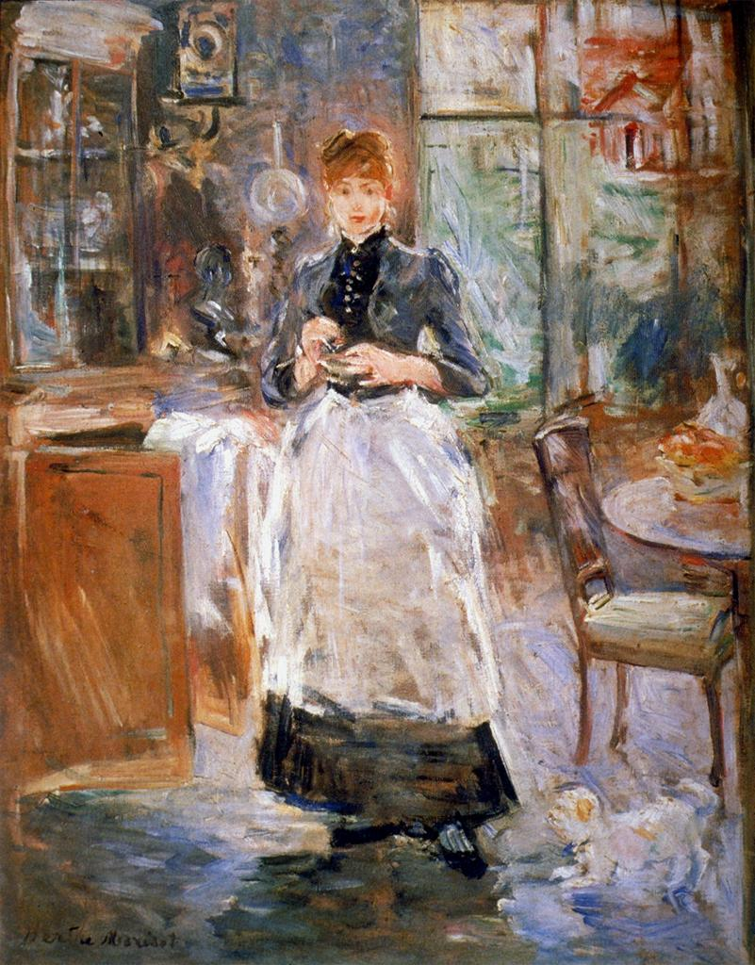

Creator | Morisot, Berthe, French
Title | The Little Serving Girl
Date | 1886
Material | o/c
Measurements | 24 x 19 1/2"
ARTstor Collection | Art History Survey Collection
Source | Catalogued by: Digital Library Federation Academic Image Cooperative
Download Size | 10,241,024

